**Ideation Phase**

**Brainstorm & Idea Prioritization Template**

|  |  |
| --- | --- |
| Date | 31 January 2025 |
| Team ID | LTVIP2025TMID38625 |
| Project Name | revolutionizing liver care |
| Maximum Marks | 4 Marks |

**Brainstorm & Idea Prioritization Template:**

## 🧠 ****Ideation Phase: Overview****

The **Ideation Phase** is a creative and strategic stage in the innovation process. It focuses on **generating, developing, and prioritizing ideas** that can solve a defined problem or improve existing solutions.

### 🎯 ****Goal:****

Generate innovative and actionable ideas to **revolutionize liver care** by improving prevention, diagnosis, treatment, or post-treatment support.

## 🧩 Key Activities in the Ideation Phase

1. **Define the Challenge:**
   * What are the current gaps or pain points in liver care?
   * Are we focusing on liver disease prevention, diagnosis, treatment, or patient follow-up?
2. **Brainstorm Ideas:**
   * Encourage open and diverse thinking without judgment.
   * Use various brainstorming techniques like:
     + **SCAMPER** (Substitute, Combine, Adapt, Modify, Put to another use, Eliminate, Reverse)
     + **Crazy 8s** (8 ideas in 8 minutes)
     + **Mind Mapping**
     + **Reverse Thinking**
3. **Group & Refine Ideas:**
   * Categorize similar ideas.
   * Identify themes or commonalities.
   * Refine ideas to make them more actionable.
4. **Prioritize Ideas:**
   * Use criteria like impact, feasibility, cost, innovation, and alignment with goals.

## 🗂️ Brainstorm & Idea Prioritization Template (Liver Care Focus)

| **Idea** | **Problem Addressed** | **Target User** | **Impact (1–5)** | **Feasibility (1–5)** | **Innovation (1–5)** | **Priority Score (Sum)** | **Next Steps** |
| --- | --- | --- | --- | --- | --- | --- | --- |
| Example: AI-driven liver fibrosis screening using smartphones | Delayed diagnosis in rural areas | Primary care doctors in low-resource settings | 5 | 4 | 5 | 14 | Build prototype |
| Personalized nutrition app for liver disease patients | Poor adherence to dietary guidelines | Liver disease patients | 4 | 5 | 4 | 13 | Partner with nutritionists |
| Liver health wearable tracker | Lack of continuous monitoring | At-risk individuals (e.g., fatty liver, hepatitis) | 5 | 3 | 4 | 12 | Conduct tech feasibility study |
| Blockchain for liver transplant records | Fragmented data across hospitals | Transplant coordinators, hospitals | 4 | 3 | 5 | 12 | Consult blockchain experts |

**Tip:** Color-code rows (green = high priority, yellow = medium, red = low) for quick visual management.

## 🧠 Suggested Brainstorming Prompts (Specific to Liver Care)

* How might we **predict liver disease earlier** using non-invasive tools?
* What technologies can help **monitor liver function remotely**?
* How can we make **liver transplant workflows more efficient**?
* In what ways could we **improve patient adherence** to treatment plans?
* What would a **digital twin of a liver patient** look like, and how could it be used?

Reference: [WHO - Liver Diseases and NCDs](https://www.who.int/news-room/fact-sheets/detail/noncommunicable-diseases)

[NIH Liver Diseases](https://www.niddk.nih.gov/health-information/liver-disease)

**Step-1: Team Gathering, Collaboration and Select the Problem Statement**

### ****Diagram Description:****

+---------------------+ +------------------------+ +-----------------------------+

| | | | | |

| Team Gathering +--------->+ Collaboration +--------->+ Select Problem Statement |

| (Experts, Stake- | | (Brainstorming, Idea | | (Critical Liver Care Gaps, |

| holders, Patients)| | Sharing, Mapping | | Patient Needs, Tech Gaps) |

| | | Priorities) | | |

+---------------------+ +------------------------+ +-----------------------------+

| ↑

v |

+-----------------------------+

| Research and Data Review |

| (Liver disease trends, AI, |

| diagnostics, healthcare |

| systems, outcomes data) |

+-----------------------------+

### ****Key Elements:****

* **Team Gathering**: Clinicians, researchers, patients, designers, policymakers.
* **Collaboration**: Workshops, design thinking sessions, cross-functional teamwork.
* **Select Problem Statement**: Define high-impact liver care challenges like early diagnosis, remote monitoring, liver transplant optimization, or personalized treatment using AI.

**Step-2: Brainstorm, Idea Listing and Grouping**

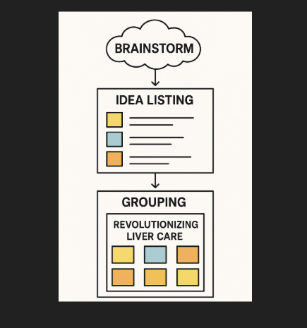

**Step-3: Idea Prioritization**

